 | 5.1.4 Topbar and Statusbar - Window menu
Table of content
Window Menu 1
Show Status Bar 1
New Window 1
New Main Window 1
Toggle Window Full screen 1
Next Workspace 1
Previous Workspace 1
Save Screenshot 1
Save Screenshot (Area) 2
Toggle System Console 2

Window Menu

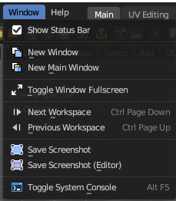
Window related functionality.

Show Status Bar
Display the footer.

New Window
Creates a new instance of Bforartists. But without Top Bar.

New Main Window
Creates a new instance of Bforartists with its own workspace and scene settings and with the Top Bar.

Toggle Window Full screen
Makes Bforartists full screen.

Next Workspace
Cycle to next workspace.

Previous Workspace
Cycle to previous workspace.

Save Screenshot
Saves a screenshot from the whole application.

Save Screenshot (Area)
Saves a screenshot from the area under the mouse.

Toggle System Console
Toggles the System console. This is a Windows feature. Under Linux and Mac you can use the bash.

